(Approx. 519 words)

Why I am a morning person!
By Lynda Buske
Published in Ottawa PC News (October 2023)
Ottawa PC Users' Group, Ontario, Canada
https://opcug.ca
Editor: brigittelord(at)opcug.ca

In a previous column, I wrote about taking photographs in the evening or nighttime. (https://opcug.ca/Photography/EveningPhotography_v3.pdf). However, I prefer to shoot in the morning, especially during the blue hour before the sun comes up. While not everyone wants to get up that early (often 4 am in the summer), there are some definite advantages and photo opportunities that you don't get in the evening.

Technically, many of the tips are similar, like compensating for low light by using a tripod, opening aperture wide (small f-stop number), bumping your ISO (sensitivity to light), or perhaps using a cell phone, which tends to cope with low light situations well. When my phone is set to "night sight," it takes multiple short exposures and combines the images into a single, appropriately exposed photo.

However, this column will discuss the non-technical advantages of shooting pre-dawn rather than post-sunset (the two blue hours). These tips, however, apply mostly to landscape photography; if you like to shoot the city nightlife, you will not find much going on in the morning. If someone is still partying, then they are probably not worth photographing!

Depending on the time of year, there is a good chance you can catch some interesting frost or mist during the morning blue hour. Both often disappear shortly after dawn when the sun burns off fog or melts frost.

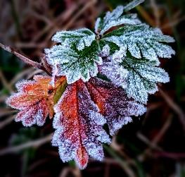
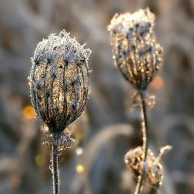

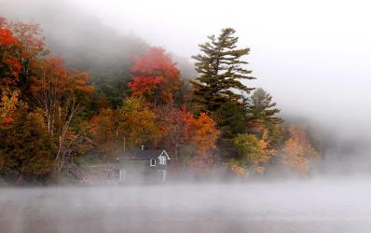

Birds get very active just after dawn. It is not just sheer luck catching migratory geese at dawn. You can hear them getting excited in the dark, and the minute the sun rises, they take off.
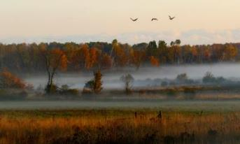
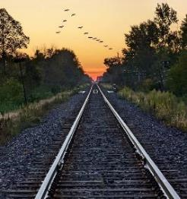
I find the early morning very relaxing. There is less city noise from traffic, especially in the summer when it is way before rush hour. Roads in the evening, regardless of the time of year, are busy before and after sunset. Parking is a breeze in the morning, and there is no competition for my favourite vantage points. If you are lakeside, the reflections are great in the morning before wind and boat traffic ruin them.

I like fewer people around, but the evening might be better if you want a lot of human interest in your photos. I usually have just enough fishermen, joggers, bikers, or kayakers to add interest if I want it. However, they seldom get in my way.

As a petite lady, I am nervous when strange men approach me in the evening. I am never sure of their intentions (innocent though they may be), and I concentrate more on picking up verbal or physical clues than on my photography. People can be distracting when asking questions about your gear (always the guys) at a critical moment when I'm trying to shift from blue hour settings to dawn settings. If someone says a few words at 5 am, I do not feel threatened, and conversations are usually short since perhaps neither of us has had a coffee! I think most of the baddies are simply not out at that hour.

